**UUS Register APIS & Forgot Password Flow**

**Register APIS Routes:**

* /ajax/user/register: Use for Registering the user**. (Reset Password Not Required)**

**Parameters Used** -

**redirectLink**: to redirect after activation done for account

**privateAppId:** to verify for security purpose of MAPIT and MATCH example: privateAppId = “mapit”.

**publicAppId:** to verify for security purpose of MAPIT and MATCH example: publicAppId= “publicmapit”.

**noMail**: **Boolean** to set true then just activation link of that account will be sent to response of API.if it set to false the activation link will be sent to user email.

**noRedirect: Boolean** used to tell redirect after activation or not always null or set to false otherwise error will be there.

**User:** user object**.**

**DB Table: registeredAppUser**

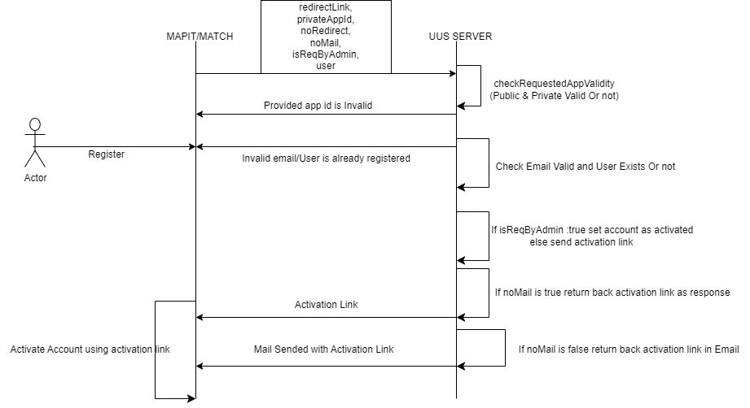

**NOTE**:

After successfully activating account user will redirect on provided redirect link.

**Link:**

<https://docs.google.com/document/d/1ZNTovb4ORxRM9u0xIjcLdJaUkcnHclPJDaAf94B8rZw/edit>

* /ajax/user/register/activate: Used for Registering and activating the user**. (Reset Password Not Required)**

**Parameters Used** -

**privateAppId:** to verify for security purpose of MAPIT and MATCH example: privateAppId = “mapit”.

**publicAppId:** to verify for security purpose of MAPIT and MATCH example: publicAppId= “publicmapit”.

**noRedirect: Boolean** used to tell redirect after activation or not always null or set to false otherwise error will be there.

**User:** user object**.**

**DB Table: registeredAppUser**

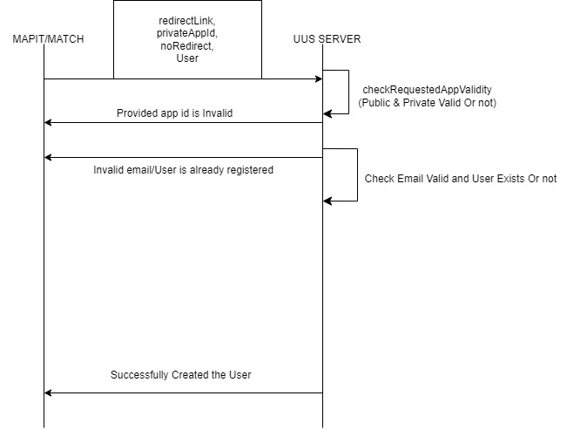

**Link:**

[**https://docs.google.com/document/d/1s9DFmdnJT81STaGhGffDZpi8cGtkawPE1Rudu4ix3DQ/edit**](https://docs.google.com/document/d/1s9DFmdnJT81STaGhGffDZpi8cGtkawPE1Rudu4ix3DQ/edit)

* /ajax/user/register/admin: Used to register user by admin without password. **(Reset Password Required)**

**Parameters Used -**

**redirectLink**: to redirect after activation done for account.

**privateAppId:** to verify for security purpose of MAPIT and MATCH example: privateAppId = “mapit”.

**publicAppId:** to verify for security purpose of MAPIT and MATCH example: publicAppId= “publicmapit”.

**sendMail**: **Boolean** to set true then just activation link of that account will be sent to response of API.if it set to false the activation link will be sent to user email.

**noRedirect: Boolean** used to tell redirect after activation or not always null or set to false otherwise error will be there.

**User:** user object**.**

**DB Table: registeredAppUser**

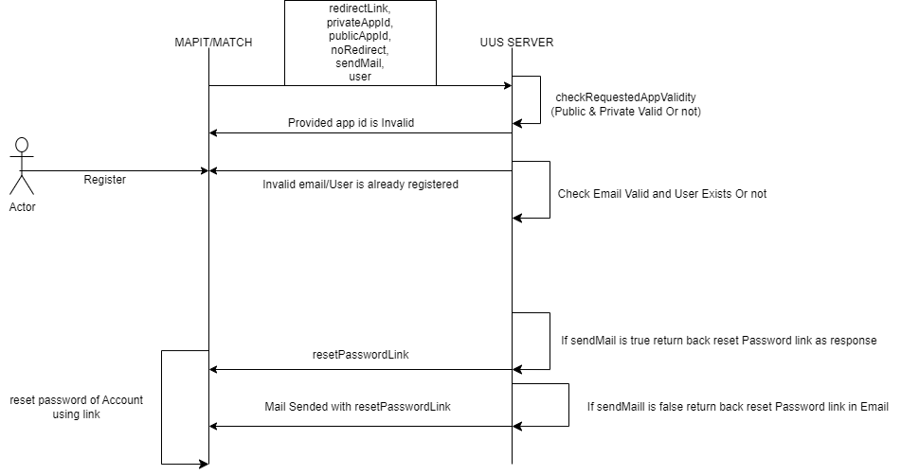

**NOTE**:

After successfully reset password of their account user will redirect on provided redirect link.

**Link:**

[**https://docs.google.com/document/d/1jO7CGsCssc7zWRT7fHYznhlA_z__QMeUdBv2hoHrxc0/edit**](https://docs.google.com/document/d/1jO7CGsCssc7zWRT7fHYznhlA_z__QMeUdBv2hoHrxc0/edit)

* /ajax/user/register/bulk this API is used to create account in bulk supported till 500 user data with optimal time can go up to 3000 but time is 21 second which is not optimal**. (Reset Password Required)**

**Parameters Used -**

**privateAppId:** to verify for security purpose of MAPIT and MATCH example: privateAppId = “mapit”.

**publicAppId:** to verify for security purpose of MAPIT and MATCH example: publicAppId= “publicmapit”.

**noRedirect: Boolean** used to tell redirect after activation or not it should always null or set to false otherwise error will be there.

**bulkList: bulk List of** user objects**.**

**DB Table: registeredAppUser**

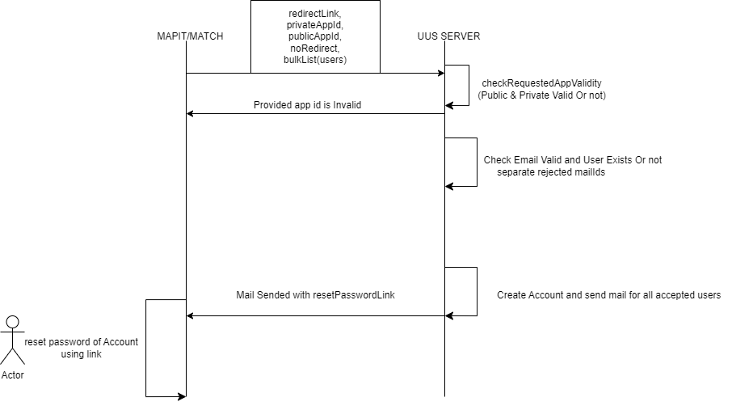

**NOTE:**

After successfully reset password of there account user will redirect on provided redirect link.

**Link :**

[**https://docs.google.com/document/d/19XBaeVOxRWcMGIrcfeZuhrYF6YNLkfakay2jiY-Olc/edit**](https://docs.google.com/document/d/19XBaeVOxRWcMGIrcfeZuhrYF6YNLkfakay2jiY-Olc/edit)

* /ajax/user/register/invite: this API is used to invite candidates only.

**Parameters Used -**

**privateAppId:** to verify for security purpose of MAPIT and MATCH example: privateAppId = “mapit”.

**publicAppId:** to verify for security purpose of MAPIT and MATCH example: publicAppId= “publicmapit”.

**noRedirect: Boolean** used to tell redirect after activation or not it should always null or set to false otherwise error will be there.

**redirectLink**: to redirect after activation done for account.

**email**: emails list of candidates to register.

**DB Table: registeredAppUser**

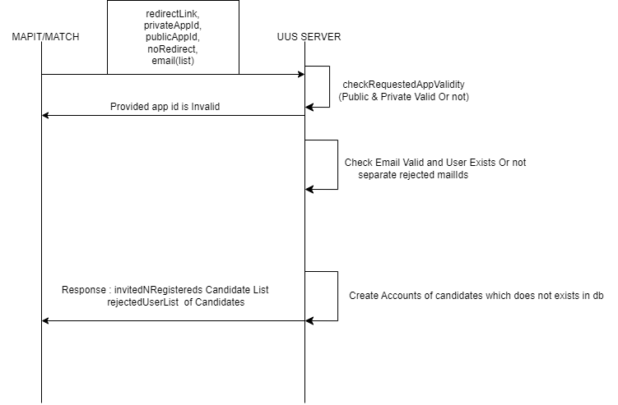

**NOTE:**

Redirect Link Option is there but there is no working in backend for that as well no reset password links no mail no activation link will be send on user account.

**Link:** <https://docs.google.com/document/d/1QMqnw57S7T4Pc8VrJOQ83IylD5sXAU643jBLDFtMCIs/edit>

**Forgot / Reset APIS Routes:**

* /ajax/user/password/reset: This api is used to reset the password of newly created account it required validation hash to match it in dB that the same account exists in uus dB or not.

**Parameters Used –**

**privateAppId:** to verify for security purpose of MAPIT and MATCH example: privateAppId = “mapit”.

**publicAppId:** to verify for security purpose of MAPIT and MATCH example: publicAppId= “publicmapit”.

**noRedirect: Boolean** used to tell redirect after activation or not it should always null or set to false otherwise error will be there.

**redirectLink**: to redirect after reset password done for account.

**email**: emails of user to reset password.

**validationHash**: It will be provided when the account was created server will check with the existing value in db.

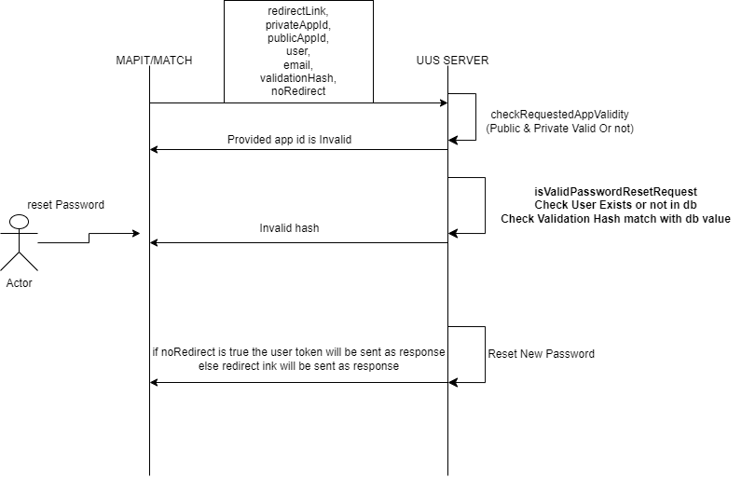

**Link:**

[**https://docs.google.com/document/d/1T4ziFMqucSSi2IFfIijV2YfXn5vC6yEYtfuf3lsNmhI/edit**](https://docs.google.com/document/d/1T4ziFMqucSSi2IFfIijV2YfXn5vC6yEYtfuf3lsNmhI/edit)

* /ajax/user/password/forgot: This api is used to forgot the password of existed account.

**Parameters Used –**

**privateAppId:** to verify for security purpose of MAPIT and MATCH example: privateAppId = “mapit”.

**publicAppId:** to verify for security purpose of MAPIT and MATCH example: publicAppId= “publicmapit”.

**noRedirect: Boolean** used to tell redirect after activation or not it should always null or set to false otherwise error will be there.

**redirectLink**: to redirect after reset password done for account.

**email**: emails of user to reset password.

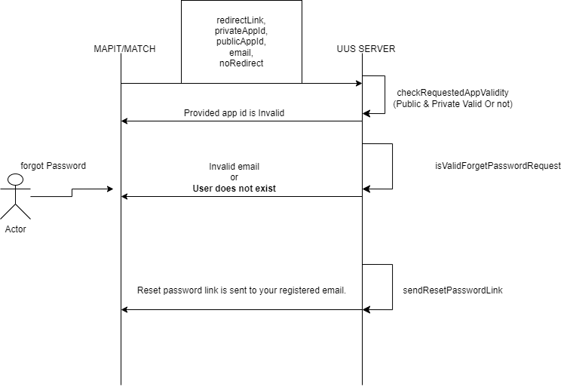

**Link:** <https://docs.google.com/document/d/1KMxSrVZOY_G_DfGev08snxraHx5o5AVmZFKBFfnvk48/edit>

**Useful Information In UUS**

**Roles In UUS for Users:**

***CANDIDATE***,

***COLLEGE***,

***CORPORATE***,

***CHANNEL_PARTNER***,

***ADMIN***